**Chemistry 12 Test Equilibrium**

**Total Marks____/45 Name:_____________________**

**Multiple Choice Section: ( 10 marks, 1 mark each)**

1. 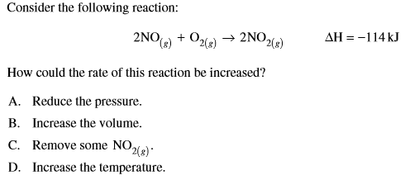

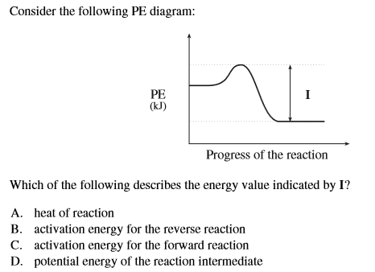

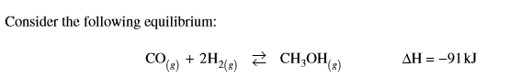

Which of the following factors will increase the yield of methanol, CH3OH?

1. Removing CH3OH from the system
2. Increasing the temperature
3. Increasing the volume
4. Decreasing the partial pressure of hydrogen
5. 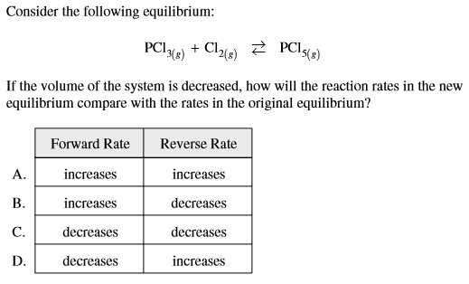
6. 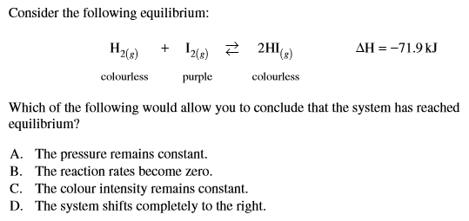
7. 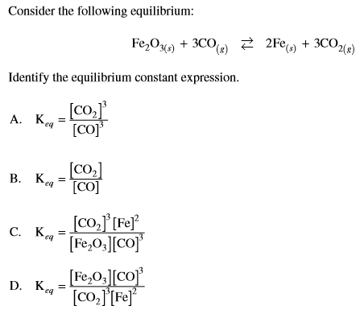
8. 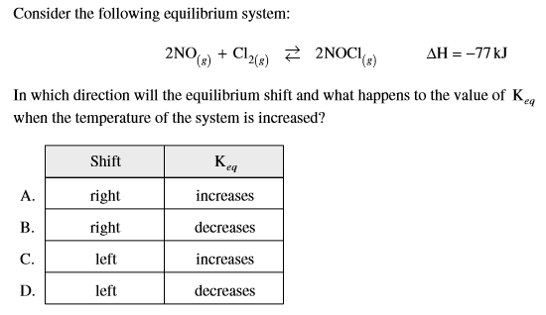

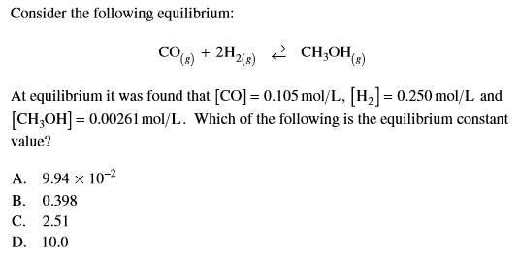8.

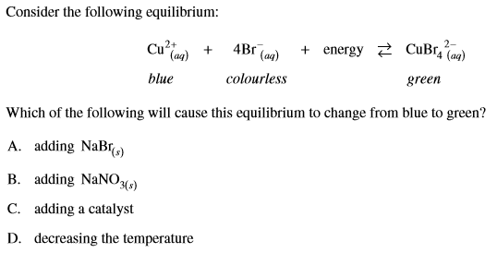

9.

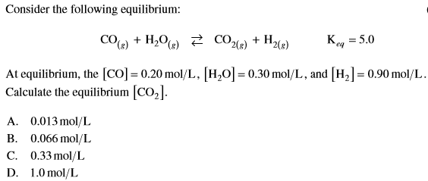

10.

**Short Answer Questions:[ 36 marks for this section]**

1. The potential energy diagram below refers to the reaction: I2(s) ⇄ I2(aq)

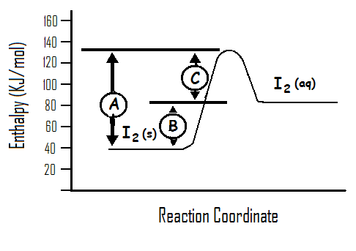

Circle which of the following statement(s) is/are FALSE? [ 2 marks ]

(a) ‘A’ is the activation energy for the reaction: I2(s) → I2(aq)

(b) ∆H for the reaction is positive and has the value ‘B’

1. At equilibrium the rate of reaction, I2(aq) → I2(s), is faster than that

of I2(s) → I2(aq)

(d) An increase in temperature will alter the equilibrium position and increase the solubility of I2

1. Consider the system shown in the diagram, where a solute solution equilibrium has been established in a beaker. Briefly explain the following:

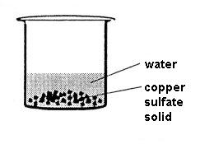a) What is happening on a macroscopic level?[ 2 marks ]

______________________________________________________

______________________________________________________

______________________________________________________

______________________________________________________

b) What is happening on a microscopic level? [ 2 marks]

_____________________________________________________________________________________

____________________________________________________________________________________________________________________________________________________________________________

______________________________________________________________________________________

c) State two ways by which the equilibrium could be altered. [ 2 marks]

____________________________________________________________________________________________________________________________________________________________________________

____________________________________________________________________________________________________________________________________________________________________________

1. The following equilibrium is being investigated. [ 6 marks ]

CH4(g) + H2O (g) ⇄ CO (g) + 3 H2 (g) ∆ H = + 200 kJ

Four identical sealed boxes are set up at 3000C and 1.00 atmosphere each containing the equilibrium

mixture. Each of the boxes is treated as described below, and timeallowed for a new equilibrium to be

established. Write what happens in each case as a result of changes.

|  |  |  |  |
| --- | --- | --- | --- |
|  | What happens to the total pressure?  Write ‘increase’, ‘decrease’ or  ‘no change’ | What happens to the partial pressure of CO?  Write ‘increase’, ‘decrease’ or  ‘no change’ | What happens to the equilibrium position?  Write ‘move to the right’, move to the left’ or ‘no change’. |
| The system is heated above 3000C |  |  |  |
| More CH4(g) at 3000C is injected into the box |  |  |  |
| Ne (g) at 3000C is injected into the box. |  |  |  |
| The volume of the box is halved. |  |  |  |

1. 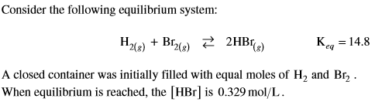

What is the equilibrium concentration of H2 gas?

[ 4 marks ]

1. 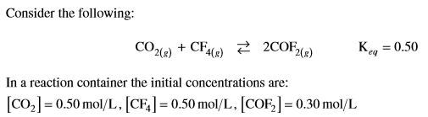

Calculate Q and state which way the reaction will shift (left toward the reactants or right toward the products or will not shift since it is at equilibrium) as a result of your calculation of Q.

[ 2 marks ]

Reaction will____________________________________________________________[1 mark]

1. Refer to the diagram below then answer the questions below.

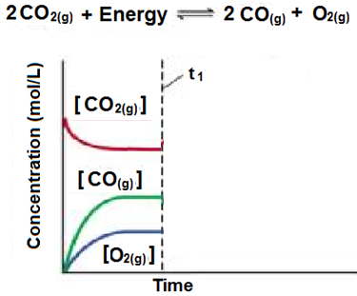

1. Draw on the above diagram what you would expect would happen to the concentration of the reactants and products if the temperature of the closed system was significantly decreased at time t1. [ 2 marks ]
2. Describe the changes you just drew on the graph above and why they occurred. [ 3 marks ]

______________________________________________________________________________________________

______________________________________________________________________________________________

______________________________________________________________________________________________

______________________________________________________________________________________________

1. Using the above concentration versus time graph draw a rate versus time graph that would correspond to this concentration versus time graph, including the changes at t1. [3 marks]
2. One step in the synthesis of nitric acid involves the following reversible reaction.

2 NO (g) + O2 (g)  2 NO2 (g) ∆ H = ̶ 114 kJ

Assume this reaction has reached equilibrium in a closed container at constant temperature and pressure.

(a) What happens (increase, decrease, no change) to the equilibrium yield of NO2 (g) if the following occur? (3 marks)

|  |  |
| --- | --- |
| **Change** | **Effect** |
| The volume of the container is increased |  |
| More oxygen is added to the container |  |
| A suitable catalyst is added. |  |

(b) What happens initially (increase, decrease, no change) to the rate of forward reaction if the following changes are made. (3 marks)

|  |  |
| --- | --- |
| **Change** | **Effect** |
| The temperature of the container is increased |  |
| More NO2 (g) is added to the container |  |
| A suitable catalyst is added. |  |